**SCIENCE ENGAGEMENT MEASURES RESEARCH PROJECT**

Supervisor: Lorna Mackenzie

Xi Yang; Farah Yeganeh

Date: 30/11/2020

1. Executive summary 5

2. Research Introduction: Aims and Objectives 7

3. Methodology 8

4. Overall Trends Over Time 10

Main findings 10

Our visit today was enjoyable 11

Our visit today was interesting 12

This visit brought science and technology alive for me 13

I have learnt/found out something new today 14

The visit made me want to further explore some of the things covered here 15

During our visit we talked to each other about what we were looking at and what we were doing 16

I feel the Science Museum is a place for me 17

The things covered here feel relevant to me and to my life 18

5. Families vs. independent adults 19

Main findings 19

Our visit today was enjoyable: 20

Our visit today was interesting 21

This visit brought science and technology alive for me 22

I have learnt/found out something new today 23

This visit made me want to further explore some of the things covered here 24

During our visit we talked to each other about what we were looking at and what we were doing 25

I feel the Science Museum is a place for me 26

The things covered here feel relevant to me and to my life 27

6. Audience Segments (2016-2019) 28

Main findings 28

Our visit today was enjoyable 29

Our visit today was interesting 30

The visit brought science and technology alive for me 31

I have found out something new today 32

The visit made me want to further explore some of the things covered here 33

During our visit we talked to each other about what we were looking at and what we were doing 34

I feel the Science Museum is a place for me 35

The things covered here feel relevant to me and to my life 36

7. NS-SEC Groups 37

Main Findings 37

Our visit today was enjoyable 39

Our visit today was interesting 40

This visit brought science and technology alive for me 41

I have learnt/found out something new today 42

The visit made me want to further explore about some of the things covered here 43

During our visit we talked to each other about what we were looking at and what we were doing 45

I feel the Science Museum is a place for me 46

The things covered here feel relevant to me and to my life 47

8. First-time Visitors vs. Regular Visitors 48

Main findings 48

Our visit today was enjoyable: 49

Our visit today was interesting: 50

This visit brought science and technology alive for me 51

I have learnt/found out something new today 52

This visit made me want to further explore about some of the things covered here 53

During our visit we talked to each other about what we were looking at and what we were doing: 54

I feel the Science Museum is a place for me: 56

The things covered here feel relevant to me and to my life 57

9. Science Interest 58

Main findings 58

Our visit today was enjoyable 59

Our visit today was interesting 60

The visit brought science and technology alive for me 61

I have learnt/found out something new today 62

The visit made me want to further explore about some of the things covered here 63

During our visit we talked to each other about what we were looking at and what we were doing 64

I feel the Science Museum is a place for me 65

The things covered here feel relevant to me and to my life 66

10. Conclusion and Recommendation 67

11. Appendices 67

Overall Trend data: Mean score average and percentage of “strongly agree” 68

Family vs. Adult visitors data: Mean score average and percentage of “strongly agree” 69

Regular vs. New visitors data: Mean score average and percentage of “strongly agree” 71

Visitor segments data: Mean score average and percentage of “strongly agree” 72

NS-SEC groups data: Mean score average and percentage of “strongly agree” 73

Science interest data: Mean score average and percentage of “strongly agree” 75

Major gallery/exhibition openings 2009/10 – 2018/19 77

# Executive summary

The Science Engagement Measures research project involves examining the data related to visitors’ engagement with science during their visit to the Science Museum London, collected as part of the SMG’s exit survey which visitors are invited to take part in at the end of their visit to the museum. The exit survey not only collects visitors’ responses to the measures, but also collects their demographic information, group type, audience segment and so on, which allows for comparisons in science engagement between these groups.

The measures were initially called Life Enhancing Experiences (LEE) and their role was to add a quantifiable measure of learning and engagement that could be tracked across years. In 2016, the measures were reviewed to ensure that they aligned with the Science Museum Group’s core priority to grow science capital in individuals and society. The updated measures were called Science Engagement Measures (SEM) and were designed to capture evidence of science engagement from which it would then be possible to infer that the museums were adhering to good Science Capital led practice. As the update from LEE to SEM resulted in only minimal changes to the measures, we can data track from the old measures to the new. The LEE and SEM are comprised of the statements as follows:

|  |  |
| --- | --- |
| Life Enhancing Experiences (LEE) | Science Engagement Measures (SEM) |
| * Our visit today was enjoyable * Our visit today was interesting * The visit brought science and technology alive for me * I have learnt something new today * The visit made me want to further explore some of the things discovered here * During our visit we talked to each other about what we were looking at and what we were doing * I feel the Science Museum is a place for me | * Our visit today was enjoyable * The visit brought science and technology alive for me * I have found out something new today (reworded) * The visit made me want to further explore some of the things discovered here * During our visit we talked to each other about what we were looking at and what we were doing * I feel the Science Museum is a place for me * The things covered here are relevant to me and my life (from 2016/17).   *Our visit today was interesting* has been taken out. |

This report is the result of comparing and analysing the responses to the science measures (LEE and SEM) of different groups of visitors over the years from 2009/2010 to 2018/19, aiming to improve the understanding of the visitors’ relationship with science and how this is impacted by their visit, as well as to provide a picture of science capital informed practice at the Science Museum London.

There are some main findings worth being noted before going into the exploration of the detailed data manifestations:

* Overall, data shows a general decline trend in terms of the strength of agreeing. It might indicate that visitors have tended to agree less with the majority of the statements over the past ten years. Despite the declining, most of the visitors have still been strongly agreeing or agreeing with the statements, showing a general positive picture.
* In 2010/11, the strength of agreement with the majority of the statements and the percentages of “strongly agree” reached the peak. It might worth an exploration into the practices of that year.
* 2012/13 was the year during which both the strength of agreement with and the percentages of “strongly agree” of the majority of the statements dropped off sharply.
* Over the past 3 years, during which the **audience segments** were added as a parameter of grouping visitors, the 8 segments did respond **differently** to some of the statements, in terms of the strength of agreement, however most of the differences have tended to be subtle.
* The **Engaged Community Drivers** have tended to agree more with the statements than visitors from other segments. The **Nostalgic Heritage Fans**, **Time-Poor Aspirers**, as well as the **Entertainment Seeker**s, however, have tended to show a slightly lower level of agreement.
* Regarding the responses from the three socio-economic groups, the differences have been very subtle when coming to “**Our visit today was enjoyable**” and “**Our visit today was interesting**”. The groups have responded relatively more differently in the other statements.
* Overall, the **student** groups have tended to respond more differently to specific statements, while the differences between responses from the **NS-SEC 1-4** and **NS-SEC 5-8** have been very little, indicating that the socio-economic might not necessarily affect the responses, as expected.
* Overall, the visitors with **strong science interests** tend to show the highest degree of agreement with most of the statements, indicating a **positive correlation** between the visitors’ science interest and the strength of their agreement with the LEE/SEM. The only exception is for “**I have learnt/found out something new today**”, where the visitors with modest science interests have rated the highest for several years.
* Since 2016/17, when the Wonderlab: The Equinor Gallery opened and Power UP! events began, the visitors with lower levels of science interests started to agree more with the statements.
* For all the socio-economic as well as science interest groups, in 2010/11, the strength of agreement with the majority of the statements reached the peak, while 2011/12 and 2012/13 are the two low points, indicating a relatively sharp drop off in 2011/12.

# Research Introduction: Aims and Objectives

This research at the Science Museum London is a part of the project which aims to examine the data related to visitors’ engagement with science during their visit to SMG sites. Two student placements, from University College London MA Museum Studies program, will analyse Science Museum’s exit survey data from 2009 to 2019, to look for trends across time and to compare results for different audience segments and demographic groups. Working with the Audience Research and Advocacy and Visitor Insight teams, the placements will also work to interpret the findings and suggest reasons for trends in the data.

The aims and specific objectives for this research are as follows.

Aims:

* To build a picture of trends in visitors’ response to the LEE/SEM over time.
* To understand how each audience segment responds to the LEE/SEM and compare this between segments.
* To understand how different NS-SEC groups respond to the LEE/SEM and compare this.
* To understand being a first-time visitor or a regular visitor affects how visitors’ respond to the LEE/SEM.
* To understand how visitors’ response to science interest questions affects their response to the LEE/SEM.
* To investigate, working with the Audience Research and Advocacy and Visitor Insight Teams, reasons for trends and differences in the LEE/SEM data.

Objectives:

* How have visitors’ responses to the LEE/SEM changed over time?
  + What, if any trends, exist in the data?
  + Are there any points in time at which there has been a significant change in visitors’ response to the LEE/SEM?
* How have visitors from different audience segments responded to the LEE/SEM?
  + Have they responded differently to the LEE/SEM? If so how？
  + Do any of these responses change over time?
* How have different NS-SEC groups responded to the LEE/SEM?
  + Does NS-SEC affect how visitors respond to the LEE/SEM? If so how?
  + Are there any differences in how NS-SEC 1-4/NS-SEC 5-8/Students respond to the to the LEE/SEM?
  + Do any of these responses change over time?
* How have first time visitors versus repeat visitors responded to the LEE/SEM?
  + Have first time visitors versus repeat visitors responded differently? If so how?
  + Does this change over time?
* How have visitors with different responses to science interest questions responded to the LEE/SEM?
  + Have visitors with different responses to the science interest questions also responded differently to the LEE/SEM? If so how?
  + Does this change over time?
* Can any reasons for trends in the data be suggested?
  + How, if at all, do trends in the data map onto changes in the museum and other contextual factors?

# Methodology

Based on data collected from the Science Museum’s exit survey, which is in the format of structured interviews, this research is mainly focusing on quantitative data analysis.

One of the research’s aims is to compare the differences of the responses from different visitors’ group. Hence, the research has interpreted the “differences of responses” into the “differences of strength of agreement” with the statements (measures).

To reach the aims and objectives, the research has planned to mainly look into the “mean score average”, as well as the “percentage of ‘strongly agree’” in the survey data. For this research, “mean score average” could be used to examine the strength of agreement with the statements, as a score tending to 2.00 indicates” strongly agree”, a score tending to 1.00 indicates “agree”, a score tending to 0.00 indicates “neither agree nor disagree”, a score tending to -1.00 indicates “disagree”, and a score tending to -2.00 indicates “strongly disagree”. The “percentage of ‘strongly agree’”, however, was used as another parameter to further illustrate the extent of visitors’ agreement with specific statements. Compared with other parameters from the data, these two were the ones which showed more obvious differences and thus were considered more appropriate for the research analysis.

# Overall Trends Over Time

In this section, it is aimed to build a picture of trends in visitors’ responses to the LEE/SEM over time and to find out the points in time at which there has been a significant change in visitors’ response to the LEE/SEM measures.

## Main findings

* Overall, data shows a general decline trend in terms of the strength of agreeing. It means that visitors have tended to less agree with the majority of the statements over the past ten years.
* Except 2010/11, the agreement to the statement “I have learnt/found out something new today” has been rising steadily.
* Except 2010/11, the decline to the agreement to the statement “The visit made me want to learn and continue exploring more about some of the things covered” has recovered in past years.
* In 2010/11, the strength of agreement with the majority of the statements and the percentages of “strongly agree” reached the peak. It means that visitors strongly agreed to the majority of the statements in this year.
* 2012/13 was the year during which both the strength of agreement with and the percentages of “strongly agree” of the majority of the statements dropped sharply.
* To investigate the reasons of the high points and fluctuations, it might worth a further exploration into the practices, events and experiences created at the Science Museum in the future studies according to the list in the appendix of this report.

Details regarding the responses to specific statements are as follows.

## Our visit today was enjoyable

* Overall, both the percentages of “strongly agree” and the strength of agreement with this statement have been through fluctuations, however, they have tended to decrease over the past ten years.
* In 2010/11, both the strength of agreement and the percentages of “strongly agree” reached the peak while they declined sharply in 2012/13 and 2014/15.
* 2018/19 was the time when visitors rated the least percentage of “strongly agree” to this statement. They have tended to agree the least that their visit was enjoyable.

## Our visit today was interesting

* Overall, both the percentages of “strongly agree” and the strength of agreement with this statement have been through fluctuations, however, they have tended to decrease over the past ten years.
* In 2010/11, both the strength of agreement and the percentages of “strongly agree” reached the peak while they declined sharply in 2012/13 and 2014/15.
* 2009/10 was the time when visitors rated the least percentage of “strongly agree” to this statement. They have tended to agree the least that their visit was interesting.

## This visit brought science and technology alive for me

* Overall, both the percentages of “strongly agree” and the strength of agreement with this statement have been through fluctuations, however, they have tended to decline over the past ten years.
* In 2010/11, both the strength of agreement and the percentages of “strongly agree” reached the peak while they declined sharply in 2012/13 and 2014/15.
* 2017/18 was the time when visitors rated the least percentage of “strongly agree” to this statement. They have tended to agree the least that their visit brought science and technology alive for them.

## I have learnt/found out something new today

* Overall, both the percentages of “strongly agree” and the strength of agreement with this statement have been through fluctuations, however, they have tended to decrease over the past ten years.
* In 2010/11, both the strength of agreement and the percentages of “strongly agree” reached the peak while they declined sharply in 2012/13.
* 2012/13 was the time when visitors rated the least percentage of “strongly agree” to this statement. They have tended to agree the least that they have learnt something new.
* Since 2015/16, data shows a general tendency of climbing up regarding the strength of agreement.

## The visit made me want to further explore some of the things covered here

* Overall, both the percentages of “strongly agree” and the strength of agreement with this statement have been through fluctuations, however, they have tended to decrease over the past ten years.
* In 2010/11, both the strength of agreement and the percentages of “strongly agree” reached the peak while they declined sharply in 2012/13.
* 2013/14 was the time when visitors rated the least percentage of “strongly agree” to this statement. They have tended to agree the least that they want to learn more.
* Since 2017/18, data shows a general tendency of climbing up regarding the strength of agreement. It has returned to where it was in 2009/10.

## During our visit we talked to each other about what we were looking at and what we were doing

* Overall, both the percentages of “strongly agree” and the strength of agreement with this statement have been through fluctuations, however, they have tended to decrease over the past ten years.
* In 2011/12, both the strength of agreement and the percentages of “strongly agree” reached the peak while they declined sharply in 2012/13.
* 2016/17 was the time when visitors rated the least percentage of “strongly agree” to this statement. They have tended to agree the least that they talked to each other.

## I feel the Science Museum is a place for me

* Overall, both the percentages of “strongly agree” and the strength of agreement with this statement have been through fluctuations, however, they have tended to decrease over the past ten years.
* In 2010/11, both the strength of agreement and the percentages of “strongly agree” reached the peak while they declined sharply in 2012/13.
* 2017/18 was the time when visitors rated the least percentage of “strongly agree” to this statement. They have tended to agree the least that they feel Science Museum is a place for them.

## The things covered here feel relevant to me and to my life

* Over the two years during which the new statement has been added into the SEM, the percentages of “strongly agree” have tended to decline very slightly.

# Families vs. independent adults

In this section, it is tried to find out how group type, being a family or an independent adult, affects how visitors respond to the LEE/SEM measures and if it changes over time.

## Main findings

* Overall, the differences between families and adults’ response to LEE/SEM measures were slight and tended to follow broadly similar patterns.
* Overall, data shows a general decline trend in terms of the strength of agreeing for both families and adults. It means that visitors have tended to less agree with the majority of the statements over the past ten years.
* Overall, except one year (2009/10) when the independent adults were more likely to agree to majority of the statements, families had the highest degree of agreement with all of the statements. With the fact that the number of the family visitors is declining, this might explain the overall declining of the strength of agreement with the measures, which the data has shown in the first section of the report.
* The only statement with adults having a very slightly higher agreement than families was “**The things covered here feel relevant to me and my life**.”
* For both types of visitors, the percentage of “strongly agree” and strength of agreement with the majority of the statements reached the peak in 2010/11 and then dropped sharply in 2012/13.
* The agreement to the two statements “**I have learnt/found out something new today**” and “**This visit made me want to further explore**” have been rising almost steadily after their decile in 2012/13.

Main details regarding each statement are as follows.

## Our visit today was enjoyable:

* Overall, except 2009/10 when adults were more likely than families to agree that their visit was enjoyable, families had a higher percentage of “strongly agree” to this statement than adults.
* Over the ten years, both the percentages of “strongly agree” and the strength of agreement have tended to decrease for both groups.
* In 2010/11, the strength of agreement and the percentage of “strongly agree” for both families and adults reached the peak while they declined in 2012/13 for families and in 2014/15 for adults. This decline was sharper for adults.
* 2009/10 for families and 2014/15 for adults was the time when they rated the least percentage of “strongly agree” to this statement.

## Our visit today was interesting

* Overall, except 2009/10 when adults were more likely than families to agree that their visit was interesting, families had a higher percentage of “strongly agree” to this statement than adults.
* Over the ten years, both the percentages of “strongly agree” and the strength of agreement they have tended to decrease for both groups.
* In 2010/11, the strength of agreement and the percentage of “strongly agree” for both families and adults reached the peak while they declined in 2012/13 for families and in 2014/15 for adults. This decline was sharper for adults.
* 2009/10 for families and 2014/15 for adults was the time when they rated the least percentage of “strongly agree” to this statement.

## This visit brought science and technology alive for me

* Overall, families were more likely than adults to agree that this visit brought science and technology alive for them.
* Over the ten years, both the percentages of “strongly agree” and the strength of agreement have been through fluctuations, however, they have tended to decrease for both groups.
* In 2010/11, the strength of agreement and the percentage of “strongly agree” for both families and adults reached the peak while they declined sharply in 2012/13 for both groups.
* 2018/19 for families and 2017/18 for adults was the time when they rated the least percentage of “strongly agree” to this statement.

## I have learnt/found out something new today

* Overall, except 2009/10 when adults were slightly more likely than families to agree that they have learnt something, families had a higher percentage of “strongly agree” to this statement than adults, with a larger gap in 2010/11.
* Over the ten years, both the percentages of “strongly agree” and the strength of agreement have been through fluctuations. Although, they have tended to decrease for both groups, it has a slight tendency of climbing up since 2013/14.
* In 2010/11, the percentage of “strongly agree” for both families and adults reached the peak while they declined sharply in 2012/13 for both groups.
* 2012/13 for both families and adults was the time when they rated the least percentage of “strongly agree” to this statement.

## This visit made me want to further explore some of the things covered here

* Overall, except 2009/10 when both adults and families equally agreed that this visit made them want to learn more, families had a higher percentage of “strongly agree” to this statement than adults. However, the difference between them was subtle.
* Over the ten years, both the percentages of “strongly agree” and the strength of agreement have been through fluctuations. Although, they have tended to decrease for both groups, it has a slight tendency of climbing up since 2014/15.
* In 2010/11, the strength of agreement and the percentage of “strongly agree” for both families and adults reached the peak while they declined sharply in 2012/13 for both groups.
* 2013/14 for families and 2016/17 for adults was the time when they rated the least percentage of “strongly agree” to this statement.

## During our visit we talked to each other about what we were looking at and what we were doing

* Overall, except 2009/10 when adults were more likely than families to agree that they talked to each other during their visit, families had a higher percentage of “strongly agree” to this statement than adults.
* Over the ten years, both the percentages of “strongly agree” and the strength of agreement have been through fluctuations. Although, they have tended to decrease for both groups.
* In 2011/12, the strength of agreement and the percentage of “strongly agree” for both families and adults reached the peak while they declined sharply in 2012/13 for both groups.
* 2009/10 for families and 2015/16 for adults was the time when they rated the least percentage of “strongly agree” to this statement.

## I feel the Science Museum is a place for me

* Overall, families were more likely than adults to agree that they feel the Science Museum is a place for them.
* Over the ten years, both the percentages of “strongly agree” and the strength of agreement have tended to decrease for both groups.
* The difference between families and adults has faded in the last two years.
* In 2010/11, the strength of agreement and the percentage of “strongly agree” for both families and adults reached the peak while they declined sharply in 2012/13 for both groups.
* 2018/19 for families and 2012/13 and 2017/18 for adults was the time when they rated the least percentage of “strongly agree” to this statement.

## The things covered here feel relevant to me and to my life

* Overall, over the two years during which the new statement has been added into the SEM, interestingly, adults had a very slightly higher agreement to this statement.

# Audience Segments (2016-2019)

The SMG has 8 audience segments, comprising Engaged Community Drivers (**ECD**), Avid Cultural Consumers (**ACC**), Trend-Awares (**TA**), Entertainment Seekers (**ES**), Passionate Specialists (**PS**), Nostalgic Heritage Fans (**NHF**), Safe Self-Improvers (**SSI**) as well as Time-Poor Aspirers (**TPA**). The data regarding audience segments and their responses to the SEM was available starting from 2016/17 to 2018/19.

## Main findings

* The **Engaged Community Drivers** have tended to agree more with the statements than visitors from other segments. The **Nostalgic Heritage Fans**, **Time-Poor Aspirers**, as well as the **Entertainment Seekers**, however, have tended to show a lower level of agreement.
* For all the segments, the highest rated statement is “**Our visit today was enjoyable**”, while “**this visit has made me want to further explore some of the things covered here**” is the lowest rated one.
* Among the three years, **2017/18** seems to be the one when the majority of the statements have received the highest level of agreements from visitors from different segments, indicating that it might be worth an exploration into the events or special occasions that might have triggered the rises. The relevant statements include: “**enjoyable**”, “**a place for me**”, “**have found out something new**” “**want to further explore**” and “**feel relevant**”.
* The audience segments did respond **differently** to some of the statements, in terms of the strength of agreement, although most of the differences tend to be subtle. All the segments have **similarly** tended to “strongly agree” with “**Our visit today was enjoyable**”, “**Our visit today was interesting**”, “**I have found out something new today**” and “**During our visit we talked to each other about what we were looking at and what we were doing”**.
* Most segments have tended to “strongly agree” that the Science Museum is a place for them. By contrast, the **Time-Poor Aspirers** have shown a relatively low level of agreement.
* Most segments have tended to “strongly agree” that their visits have brought science and technology alive for them. However, the **Nostalgic Heritage Fans** and **Time-poor Aspirers** have relatively low degrees of agreement.
* The **Nostalgic Heritage Fans,** **Time-poor Aspirers**, **Passionate Specialists** and **Entertainment Seekers** showed a lower level of motivation to learn more or continue exploring about the things covered by their visits.
* The visitors from the **Entertainment Seekers** have the lowest degree of agreement with the statement “**The things covered here feel relevant to me and to my life**”.

More details regarding the responses of visitors from different segments are as follows.

## Our visit today was enjoyable

* On average, the strength of agreement from Time Poor Aspirers has tended to be the lowest. Those of the Nostalgic Heritage Fans and Safe Self-Improvers tend to be relatively low as well. The Engaged Community Drivers as well as Avid Cultural Consumer are the two segments which agree more with the statement.

|  |
| --- |
|  |
|  |

## Our visit today was interesting

* On average, the strength of agreement of Time Poor Aspirers has tended to be the lowest. Those of the Nostalgic Heritage Fans, Safe Self-Improvers and Entertainment Seekers tend to be relatively low as well. The Engaged Community Drivers as well as Avid Cultural Consumer are the two segments which agree more with the statement.

|  |
| --- |
|  |
|  |

## The visit brought science and technology alive for me

* The Time Poor Aspirers segment tends to be the lowest over the three years. The differences in the strength of agreement are not so obvious among Avid Cultural Consumers, Nostalgic Heritage Fans, Trend Awares, Passionate Specialists, and Entertainment Seekers. The Engaged Community Drivers is the segment which has the highest level of agreement.

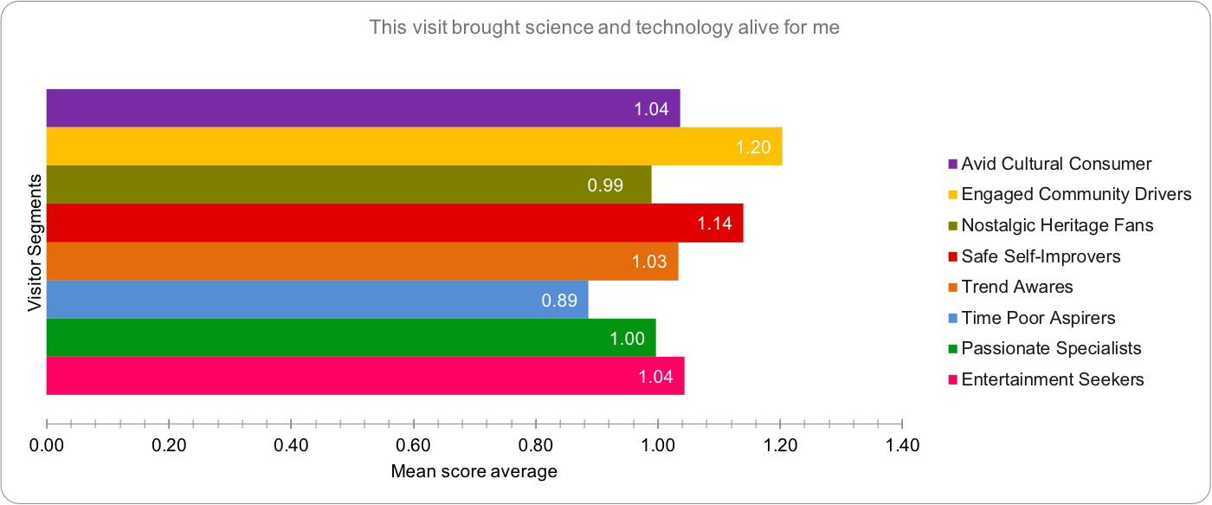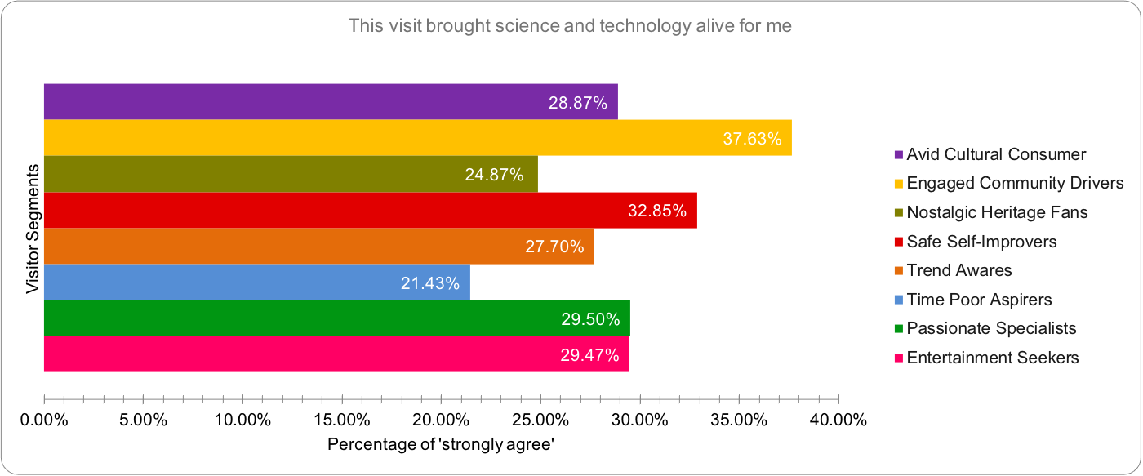

|  |
| --- |
|  |
|  |

## I have found out something new today

* On average, the Time Poor Aspirers and Passionate Specialists segments tend to be the joint lowest over the three years. The differences among the responses of the Avid Cultural Consumer, Safe Self-Improvers and Trend Awares are not obvious, while the Engaged Community Drivers is the segment which has the highest level of agreement.

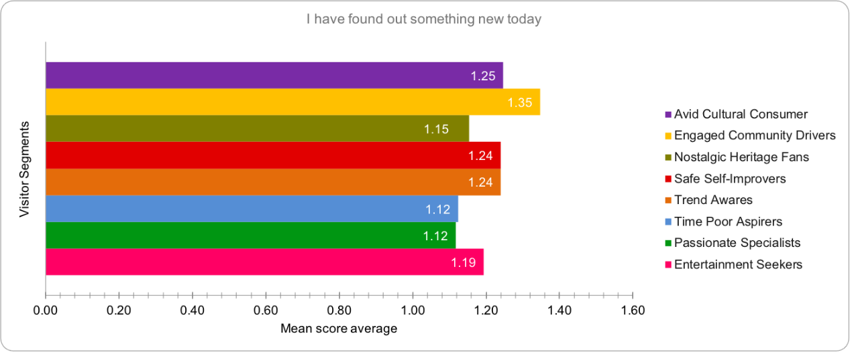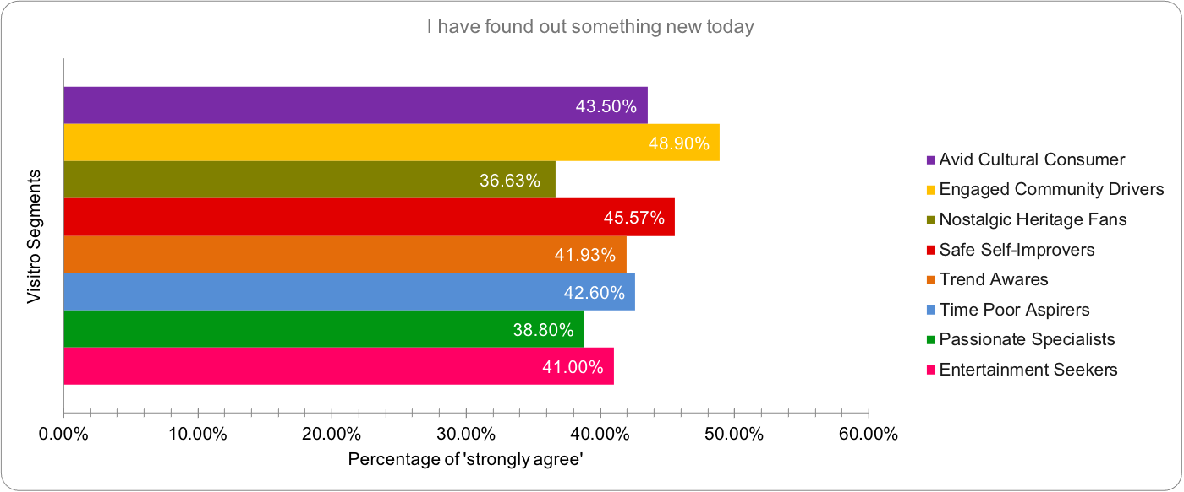

|  |
| --- |
|  |
|  |

## The visit made me want to further explore some of the things covered here

* On average, the Time Poor Aspirers tends to be the lowest regarding the strength of agreement over the three years. The Engaged Community Drivers is the segment which has the highest level of agreement.

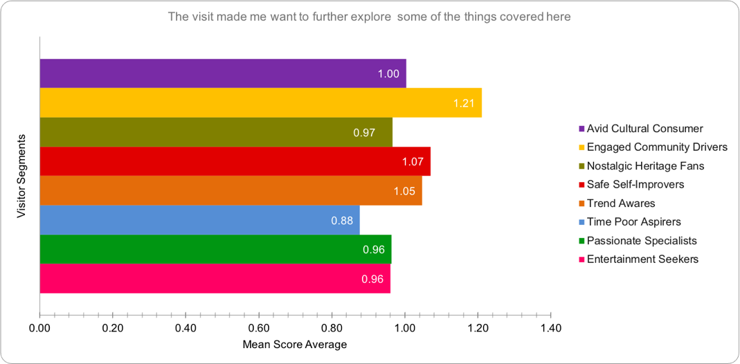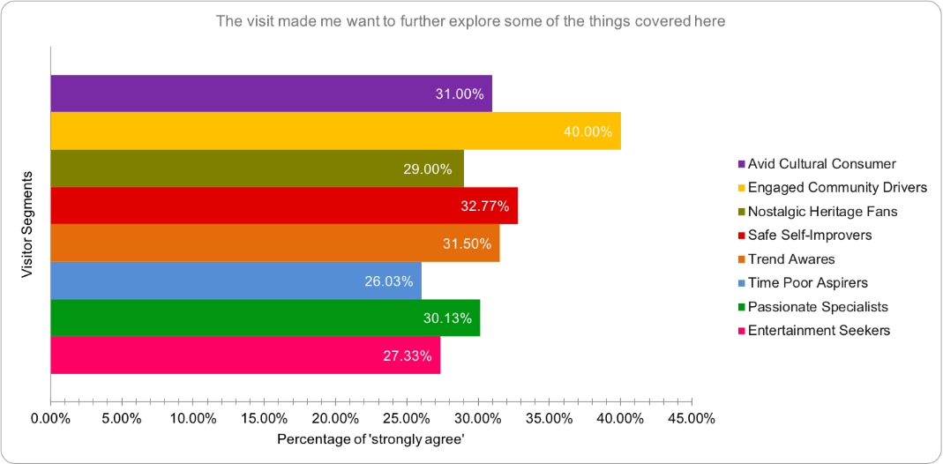

|  |
| --- |
|  |
|  |

## During our visit we talked to each other about what we were looking at and what we were doing

* On average, the Time Poor Aspirers tends to be the lowest regarding the strength of agreement over the three years. The Avid Cultural Consumer is the segment which has the highest level of agreement, with 50% of the visitors “strongly agreeing” with the statement.

|  |
| --- |
|  |
|  |

## I feel the Science Museum is a place for me

* On average, the strength of agreement of the Time Poor Aspirers segment tends to be the lowest over the three years. The Nostalgic Heritage Fans and Safe Self-Improvers tend to agree less as well. The Avid Cultural Consumers and Engaged Community Drivers remain the two segments which have the highest level of agreement.

|  |
| --- |
|  |
|  |

## The things covered here feel relevant to me and to my life

* On average, the Entertainment Seekers tend to be the lowest regarding the strength of agreement over the three years. The Avid Cultural Consumer is the segment which has the highest level of agreement. The Nostalgic Heritage Fans, Time Poor Aspirers as well as the Entertainment Seekers have shown a lower degree of agreement.

|  |
| --- |
|  |
|  |

# NS-SEC Groups

The National Statistics Socio-economic Classification is the official socio-economic classification in the United Kingdom. It is commonly used in eight-class, five-class and three-class versions. The version intended for most users has eight classes:

1. Higher managerial and professional occupations
2. Lower managerial and professional occupations
3. Intermediate occupations (clerical, sales, service)
4. Small employers and own account workers
5. Lower supervisory and technical occupations
6. Semi-routine occupations
7. Routine occupations
8. Never worked or long-term unemployed

Based on this version, the Science Museum has categorised the visitors into three interrelated groups: NS-SEC 1-4, NS-SEC 5-8 and Students. “Students” as a group type is not included in the national classification system.

## Main Findings

* The differences in the responses of the three groups have been very subtle regarding “**Our visit today was enjoyable**” and “**Our visit today was interesting**” over the ten years. However, the **NS-SEC 1-4** have been finding their visits slightly more enjoyable and interesting than the other two do, while the **students** seem to have been having the least fun.
* For all the groups, in 2010/11, the strength of agreement with the majority of the statements (6 out of 7) reached the peak, while 2011/12 and 2012/13 are the two low points, indicating that since 2010/11, there has been a general decline in agreement.
* Since 2013/14, all the three groups have been tending to show more motivations to **further explore** some of the things covered at the Science Museum, while the **students** seem to be motivated the most.
* Since 2012/13, the **students** have been talking less to each other during their visits, compared with the **NS-SEC 5-8** and **NS-SEC 1-4**.
* From 2013/14 to 2017/18, the **students** had been tending to agree the least that the **Science Museum is a place for them**. In 2018/19, however, they showed the highest degree of agreement with this statement. The differences in the responses of the **NS-SEC 1-4** and **NS-SEC 5-8** have been very little.
* Over the two years during which the new statement “**The things covered here feel relevant to me and to my life”** has been added into the SEM, all of the groups interviewed in 2018/19 tended to agree less than those in 2017/18. The **NS-SEC 5-8** has changed the most regarding the strength of agreement, with the percentage of “strongly agree” dropping from 36% in 2017/18 to 25.30% in 2018/19.

More details regarding the responses to the LEE/SEM from different NS-SEC groups are as follows.

## Our visit today was enjoyable

* Overall, the visitors from **NS-SEC 1-4** have tended to agree with the statement the most and the students have tended to agree the least. However, the differences among groups have been subtle.
* Over the past 10 years, for all the three groups, data shows a general decline trend in terms of the strength of agreeing; both the strength of agreement and the percentages of “strongly agree” reached the peak in 2010/11

## Our visit today was interesting

* Over the past years, the visitors from **NS-SEC 1-4** have been more tending to “strongly agree” that their visits were interesting, while the students have been finding the least fun during the visits. However, the differences among the groups have been little.
* Over the past ten years, for all the three groups, data shows a general decline trend in terms of the strength of agreeing; both the percentages of “strongly agree” and the strength of agreement reached the peak in 2010/11.

## This visit brought science and technology alive for me

* There is no continuous pattern regarding the differences of the responses from the NS-SEC groups. Before 2015/16, the **NS-SEC 1-4** had tended to agree the most with the statement; after 2015/16, however, the strength of agreement of both **NS-SEC 5-8** and **Students** has been rising; since 2017/18, **students** have become the ones who agree the most.
* Over the ten years, for all the three groups, both the percentages of “strongly agree” and the strength of agreement have been through fluctuations, without consistent changing patterns; 2010/11 seems to be a high point of the strength of agreement of all the groups, while 2011/12 and 2014/15 are likely the two low points.

## I have learnt/found out something new today

* Before 2011/12, **students** had tended to agree the most with the statement. With time passing by, however, the differences among the responses from the three groups have been little.
* From 2009/10 to 2014/15, for all the three groups, the percentages of “strongly agree” and the strength of agreement reached the peak in 2010/11, then dropped sharply.
* Since 2014/15, all the three groups seem to have a slight tendency of climbing up, in terms of the strength of agreement. However the variances have been subtle.

## The visit made me want to further explore about some of the things covered here

* Before 2014/15, the differences in the responses of the three groups were more obvious. The strength of agreement of the **NS-SEC 5-8** had been much lower than the other two groups; Since 2014/15, however, the differences have gradually become more subtle; Since 2017/18, the **students** have tended to agree more with the statement.
* Since 2012/13, the strength of agreement of the **NS-SEC 5-8** has been steadily rising.
* Since 2016/17, the strength of agreement of the **student** group has been rising specifically fast, making it the one who agrees the most in both 2017/18 and 2018/19.
* Over the years, the strength of agreement of both the **NS-SEC 5-8** and the **student** group have reached the peak in 2010/11.
* In 2014/15, the strength of agreement of the **NS-SEC 1-4** has dropped off sharply.
* Since 2013/14, for all the three groups, data shows a general tendency of increasing regarding the strength of agreement.

## During our visit we talked to each other about what we were looking at and what we were doing

* The differences of the response had been very subtle before 2012/13. After that year, the **students** have tended to agree the least with the statement.
* Over the ten years, for all the three groups, data shows a general decline trend in terms of the strength of agreement, starting with a relatively sharp drop off in 2012/13.
* The responses from the **NS-SEC 5-8** and **NS-SEC 1-4** seems to have little difference.

## I feel the Science Museum is a place for me

* In 2012/13, there has been a relatively sharp drop off regarding both the strength of agreement and the percentage of “strongly agree”, for all the three groups.
* Over the ten years, the responses from the **NS-SEC 5-8** and **NS-SEC 1-4** seems to have little difference.
* From 2013/14 to 2017/18, the **students** had been tending to agree the least that the Science Museum is a place for them. In 2018/19, however, they showed the highest degree of agreement with the statement.
* The responses from both **NS-SEC 5-8** and **NS-SEC 1-4** have not been changing obviously since 2012/13.

## The things covered here feel relevant to me and to my life

* Over the two years during which the new statement has been added into the SEM, all the groups interviewed in 2018/19 tended to agree less than those in 2017/18.
* The **NS-SEC 5-8** has changed the most regarding the strength of agreement, with the percentage of “strongly agree” dropping from 36% in 2017/18 to 25.30% in 2018/19.

|  |
| --- |
| First-time Visitors vs. Regular Visitors In this section, it is tried to find out how the first-time visitors versus regular visitors (visitors who make at least two visits per year) have responded to LEE/SEM measures and if it changes over time. Main findings  * Overall, the differences between first-time visitors and regular visitors’ response to LEE/SEM measures were slight and tended to follow broadly similar patterns. * Regular visitors tend to show the highest degree of agreement with the majority of the statements. The only exception was “**I have learnt something new today**”, where new visitors on average have rated higher than regular visitors. * For both types of visitors, the strength of agreement with the majority of the statements reached the peak in 2010/11 and then dropped sharply in 2012/13 and 2014/15. * 2009/10 to 2011/12 was a period during which there was a very little difference between both new and regular visitors, and they were equally likely to agree with the majority of statements.   More details regarding the responses to the LEE/SEM from first-time and regular visitors are as follows. Our visit today was enjoyable:  * Overall, except a period of three years (2009/10 to 2011/12) when there was a very little difference between both types of visitors and they equally agreed that their visit was enjoyable, regular visitors had the higher percentage of “strongly agree” to this statement. * Over the ten years, both the percentages of “strongly agree” and the strength of agreement have been through fluctuations, however, they have tended to decrease for both groups. * In 2010/11, the strength of agreement and the percentage of “strongly agree” for both new and regular visitors reached the peak while they declined sharply in 2014/15 for both groups. * 2017/18 for new visitors and 2018/19 for regular visitors was the time when they rated the least percentage of “strongly agree” to this statement.  Our visit today was interesting:  * Overall, except a period of two years (2009/10 to 2010/11) when new visitors were slightly more likely to agree that their visit was interesting, from 2011/12 onwards （until 2016/17 before this statement was replaced) regular visitors had the higher percentage of “strongly agree” to this statement. * Over the ten years, both the percentages of “strongly agree” and the strength of agreement have been through fluctuations, however, they have tended to decrease for new visitors more than regular visitors. * In 2010/11, the strength of agreement and the percentage of “strongly agree” for both new and regular visitors reached the peak while they declined sharply in 2014/15 for both groups, but the worst for new visitors. * 2014/15 was also the time when new and regular visitors rated the least percentage of “strongly agree” to this statement.    This visit brought science and technology alive for me  * Overall, except non-consecutive five years (2009/10 to 2011/12, 2014/15 and 2018/19) when new visitors were slightly more likely to agree that their visit brought science and technology alive for them, on average regular visitors had a slightly higher percentage of agreement than new visitors. * Over the ten years, both the percentages of “strongly agree” and the strength of agreement have been through fluctuations, however, they have tended to decrease for both groups. * In 2010/11, the strength of agreement and the percentage of “strongly agree” for both new and regular visitors reached the peak while they declined significantly in 2014/15 for both groups, with 2017/18 the worst for the new visitors. * 2017/18 for new visitors and 2018/19 for regular visitors was the time when they rated the least percentage of “strongly agree” to this statement.  I have learnt/found out something new today  * Overall, for non-consecutive six years (from 2009/10 to 2011/12, in 2013/14, 2014/15 and 2018/19) it was new visitors who were slightly more likely to agree that they have learnt something new. On average, new visitors had a slightly higher percentage of “strongly agree” to this statement than regular visitors. * Over the ten years, both the percentages of “strongly agree” and the strength of agreement have been through fluctuations. Although, they have tended to decrease for both groups, it has a slight tendency of climbing up for new visitors since 2015/16. * In 2010/11, the strength of agreement and the percentage of “strongly agree” for both new and regular visitors reached the peak while they declined sharply in 2012/13 for both groups. * 2012/13 for new visitors and 2009/10 for regular visitors was the time when they rated the least percentage of “strongly agree” to this statement.    This visit made me want to further explore about some of the things covered here  * Overall, except a period of two years (2009/10 to 2011/12) when there was a very little difference between both types of visitors and they equally agreed that their visit made them want to learn more about science and technology and 2011/12 when new visitors rated slightly higher to this statement than regular ones, from 2012/13 onwards, it was regular visitors who had a higher percentage of “strongly agree” to this statement. * Over the ten years, both the percentages of “strongly agree” and the strength of agreement have been through fluctuations. Although, they have tended to decrease for both groups, it has a slight tendency of climbing up for new visitors since 2017/18. * In 2010/11, the strength of agreement and the percentage of “strongly agree” for both new and regular visitors reached the peak while they declined sharply in 2012/13 for both groups. * 2013/14 for new visitors and 2014/15 for regular visitors was the time when they rated the least percentage of “strongly agree” to this statement.    During our visit we talked to each other about what we were looking at and what we were doing:  * Overall, except 2009/10 when there was no difference between both types of visitors and they equally agreed that during their visit they talked to each other about what they were looking at and what they were doing and 2010/11 when new visitors rated slightly higher to this statement than regular ones, from 2011/12 onwards, it was regular visitors who had a higher percentage of “strongly agree” to this statement. * Over the ten years, both the percentages of “strongly agree” and the strength of agreement have been through fluctuations. Although, they have tended to decrease for both groups, it has a slight tendency of climbing up for new visitors in 2018/19. * In 2010/11, the strength of agreement and the percentage of “strongly agree” for both new and regular visitors reached the peak while they declined sharply in 2012/13 for both groups. * 2017/18 for new visitors and 2018/19 for regular visitors was the time when they rated the least percentage of “strongly agree” to this statement.    I feel the Science Museum is a place for me:  * Overall, from 2009/10 to 2018/19, it was regular visitors who had a higher percentage of “strongly agree” to this statement. * Over the ten years, both the percentages of “strongly agree” and the strength of agreement have been through fluctuations. Although, they have tended to decrease for both groups, it has a slight tendency of climbing up for new visitors in 2018/19. * In 2010/11, the strength of agreement and the percentage of “strongly agree” for both new and regular visitors reached the peak while they declined sharply in 2012/13 for both groups. * 2017/18 for new visitors and 2018/19 for regular visitors was the time when they rated the least percentage of “strongly agree” to this statement.    The things covered here feel relevant to me and to my life  * Overall, over the two years during which the new statement has been added into the SEM, it was regular visitors who had slightly a higher percentage of “strongly agree” to this statement. * In 2017/18, regular visitors rated a s higher percentage of “strongly agree” to this statement than new ones. * In 2018/19, while there was a slight increase in the percentage for new visitors, there was a slight decrease for regular visitors. |

# Science Interest

The visitors were invited to answer several sciences interests’ questions in the exit survey of the Science Museum. Based on the answers, the visitors were then categorised into three groups, each of which has different level of interests in Science subjects: **Strong**, **Modest** and **Weak**. The research also investigates how this might influence their responses to the measures.

## Main findings

* Overall, the visitors with strong science interests tend to show the highest degree of agreement with the majority of the statements, indicating a **positive correlation** between the visitors’ **science interest** and the **strength of their agreement** with the LEE/SEM. The only exception is for “**I have learnt something new today**”, where the visitors with modest science interests have rated the highest for several years.
* Among the LEE/SEM, the strength of agreement tends to be affected less by the visitors’ science interest when coming to “**I have learnt something new today**” and “ **during our visit we talked to each other about what we were looking at and what we were doing**”.
* For all the three groups, the strength of agreement with most of the statements reached the peak in 2010/11 and then dropped sharply in 2012/13.
* In 2014/15, the percentage of “strongly agree” with the statement “**During our visit we talked to each other about what we were looking at and what we were doing**” rose sharply among all the three groups, then dropped sharply and has been changing little.
* 2016/17 is a high point for the visitors with **weak science interests**. Their agreement with “**the visit brought science and technology alive for me**”, “**I have learnt something new today**” and “**I want to learn more/continue exploring some of the things covered here**” rose sharply. The Wonderlab and the Power UP! which opened in that year might be the main reasons.
* Since 2016/17, the visitors who have modest and weak science interests have started to agree more that the **Science Museum is a place for them**, while the strength of agreement of the “strong interest” group dropped sharply. It is worth being noted that in 2018/19, visitors with **weak science interest** become the one who agree the most.

More detailed findings regarding specific statements are as follows.

## Our visit today was enjoyable

* Overall, the visitors with strong science interests tend to agree with the statement the most, followed by the modest-interested ones and then the weak-interested ones.
* For all the three groups, data shows a slight decline in terms of the strength of agreeing over the past ten years; the percentages of “strongly agree” reached a peak in 2010/11.
* The majority of the visitors, regardless of how strong their interests in Science are, tend to strongly agree with the statement.

## Our visit today was interesting

* Overall, the visitors with strong interests in Science tend to rate the highest, compared with the ones with modest and weak interests.
* For all the three groups, data shows a slight tendency of decline in terms of the strength of agreement; the percentage of “strongly agree” reached a peak in 2010/11.

## The visit brought science and technology alive for me

* Over the years, the visitors with strong interests in science showed the highest degree of agreement.
* For all the three groups, data shows a tendency of decline in terms of the strength of agreement; the percentages of “strongly agree” reached the peak in 2010/11.

## I have learnt/found out something new today

* Except for 2010/11 and 2012/13, the visitors with strong interests in science showed the highest degree of agreement.
* The percentages of “strongly agree” reached the peak in 2010/11 and dropped sharply in 2012/13, then have varied very little until 2018/19.

## The visit made me want to further explore about some of the things covered here

* Over the 10 years, the visitors with strong interests in science showed the highest degree of agreement.
* For all the three groups, the percentages of “strongly agree” reached the peaks in 2010/11 (“modest” and “weak”) and 2011/12(“strong”), but all dropped sharply in 2012/13.

## During our visit we talked to each other about what we were looking at and what we were doing

* Over the 10 years, the visitors with strong interests in science showed the highest degree of agreement.
* For all the three groups, the percentages of “strongly agree” have all dropped sharply in 2012/13 and risen relatively high in 2014/15 then dropped again.

## I feel the Science Museum is a place for me

* Before 2017/18, the visitors with strong interests in science showed the highest degree of agreement. However, the visitors who have modest and even weak interest have started to agree more since 2016/17, while the strength of agreement dropped sharply.
* For all the three groups, the percentages of “strongly agree” have all dropped sharply in 2012/13.
* In 2018/19, the visitors with weak science interest become the ones who agree the most with the statement.

## The things covered here feel relevant to me and to my life

* Over the 2 years when this statement was added to the SEM, the visitors with strong interests in science showed the highest degree of agreement.

|  |
| --- |
| Conclusion and Recommendation  * Overall, the scores for the LEE/SEM show a general decline over the past ten years. However, it is worth mentioning that despite the decline, most of the visitors have been strongly agreeing or agreeing with the statements, showing a general positive picture. * Most of scores of the statements have reached the peaks in 2010/11, dropped off sharply in the following one or two years, then have been fluctuating slightly until 2018/19. Hence, it might be beneficial to look more into the years when the scores are obviously higher to learn from the good practices, as well as into the years when the scores are dropping off sharply, to investigate the possible reasons. * Generally, to enhance the visitors’science engagement, it is recommended to look into, reflect on and learn from 2010/11’s practices and experiences created for the visitors, based on the fact that this year is the high point of visitors’ agreement with the LEE/SEM over the past ten years. * Regarding different audience segments, there might be more potentials for us to enhance the science engagement of Entertainment Seekers during their museum visits. They are one of the groups who have given relatively lower scores to the statements, but are also more elastic in terms of time and interests, compared with Nostalgic Heritage Fans and Time-Poor Aspires, the other two groups whose strength of agreement is weaker. * The social economic status might create less impact than we expected, because the data shows few obvious patterns regarding the differences in the responses from the NS-SEC 1-4 and NS-SEC 5-8. The students’ group, which is out of the national classification, however, do seem to respond more differently. Hence, it might worth an explore into this specific group. Another factor that also needs to be taken into consideration could be the specific type of the students (are they high school, university or post-graduate students?), which could be a possible direction for the future study. * The practices from 2016/17 are worth further exploring and learning from, especially if the museum planned to specifically enhance the experience of the visitors with lower science interests. The visitors with a relatively lower passion in science and technology show an obvious positive attitude towards the majority of the statements in 2016/17.  Appendices |

## Overall Trend data: Mean score average and percentage of “strongly agree”

## Family vs. Adult visitors data: Mean score average and percentage of “strongly agree”

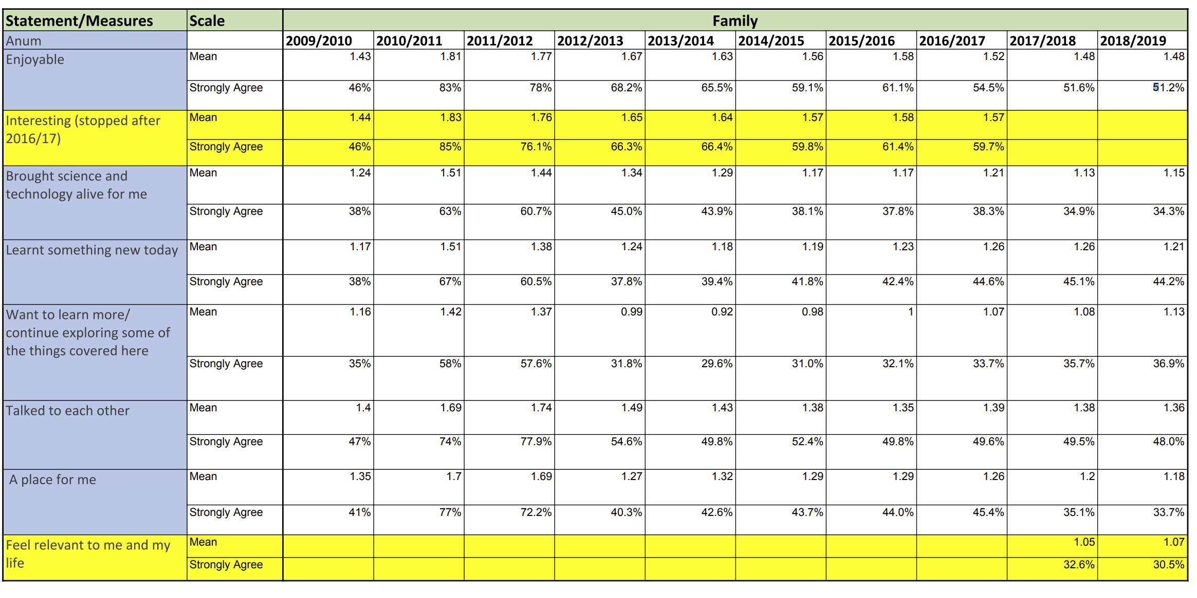

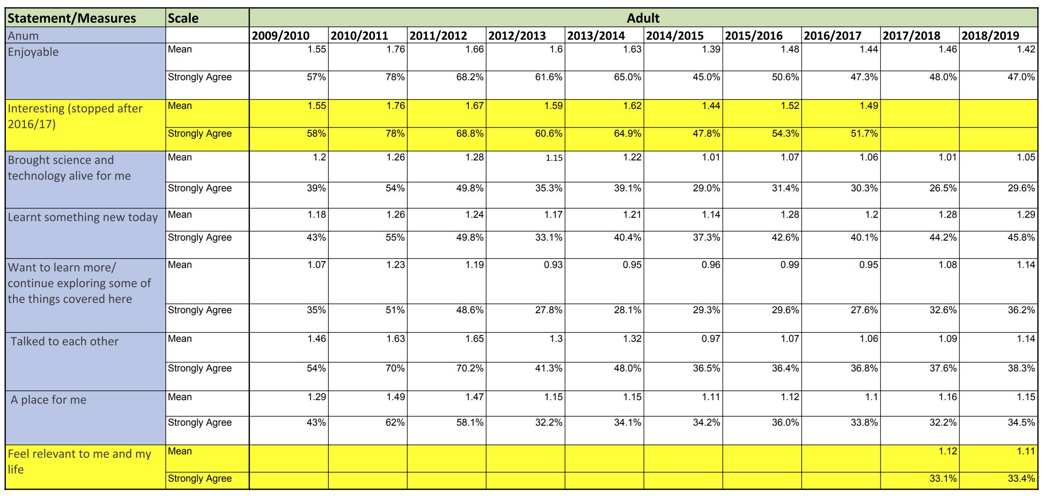

## Regular vs. New visitors data: Mean score average and percentage of “strongly agree”

## Visitor segments data: Mean score average and percentage of “strongly agree”

## NS-SEC groups data: Mean score average and percentage of “strongly agree”

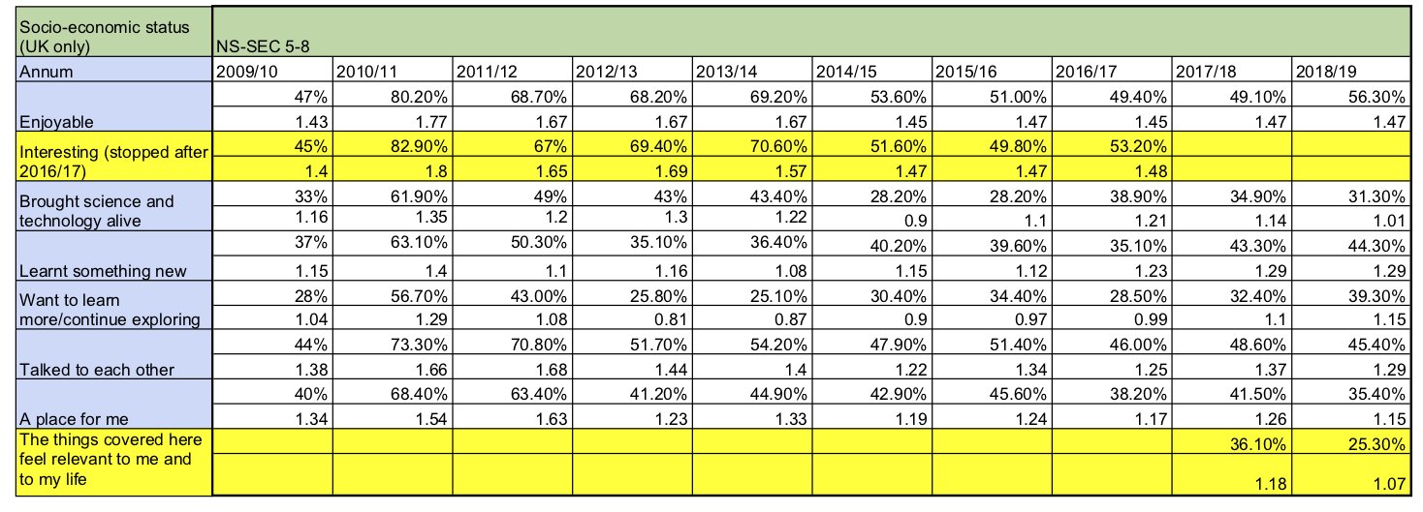

## Science interest data: Mean score average and percentage of “strongly agree”

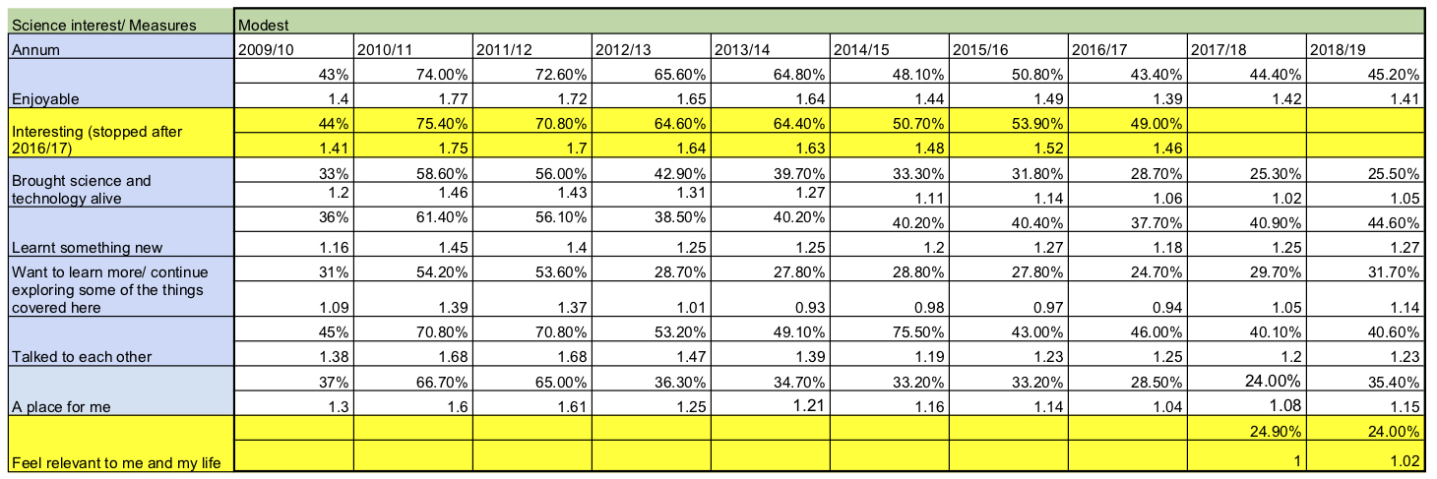

## Major gallery/exhibition openings 2009/10 – 2018/19

2009/10 [Annual Report](https://www.sciencemuseumgroup.org.uk/wp-content/uploads/2017/06/annual-report-accounts-2009-10.pdf)

* World Class Service accreditation
* Year of special events for Centenary of the Museum
  + Space season of family events for 40th anniversary of the moon landings
* Cosmos & Culture: How Astronomy has shaped our World exhibition
* Future Food exhibition
* 1001 Inventions – how Muslim heritage shaped our World exhibition
* Lates launched January 2009
  + Attracting young adults

2010/11 [Annual Report](https://www.sciencemuseumgroup.org.uk/wp-content/uploads/2017/06/annual-report-accounts-2010-11.pdf)

* Redevelopment of the Wellcome Wing
  + Opened Atmosphere gallery
  + Relaunch of Who Am I? gallery
  + Relaunch of Antenna gallery
* James Watt and Our World exhibition
* First Time Out exhibition

2011/12 [Annual Report](https://assets.publishing.service.gov.uk/government/uploads/system/uploads/attachment_data/file/229181/0382.pdf)

* Hidden Heroes: The Genius of Everyday Things exhibition
* Stephen Hawking objects and papers displayed
* Festivals: Robotville Festival, Player live gaming weekend, Sticked Science event
* Climate change displays

2012/13 [Annual Report](https://assets.publishing.service.gov.uk/government/uploads/system/uploads/attachment_data/file/246510/0519.pdf)

* Significant increase in overseas visitors during the Olympic year
* Codebreaker exhibition
* Web Lab exhibition
* Signs, Symbols, Secrets: An illustrated guide to alchemy. Exhibition
* Universe of Sound exhibition
* Made in Britain exhibition
* Climate Changing stories exhibition
* Pain Less exhibition
* The Voice of the BBC exhibition
* Festivals: Zombie Lab, High Performance Festival

2013/14 [Annual Report](https://www.sciencemuseumgroup.org.uk/wp-content/uploads/2017/06/annual-report-accounts-2013-14.pdf)

* Media Space photography and art galleries opened
* 3D printing the future exhibition
* Collider exhibition
* Antenna Live events
* Mind Maps Stories from Psychology exhibition

2014/15 [Annual Report](https://www.sciencemuseumgroup.org.uk/wp-content/uploads/2017/06/annual-report-accounts-2014-15.pdf)

* Information gallery
* Engineer Your Future gallery
* Unlocking Lovelock exhibition
* The Rubbish Collection exhibition
* Open for Business exhibition
* Churchills Scientists exhibition
* Cravings: Can Your Food Control You? Exhibition

2015/16 [Annual Report](https://www.sciencemuseumgroup.org.uk/wp-content/uploads/2017/06/annual-report-accounts-2015-16.pdf)

* Journey’s Through Medicine temporary display
* Cosmonauts exhibition
* Ada Lovelace The Enchantress of Numbers exhibition
* The Clockmakers Museum gallery
* Einstein’s Legacy exhibition
* Leonardo da Vinci The Mechanics of Genius exhibition
* Mathematics Gallery closed to the public
* Launchpad closed to the public

2016/17 [Annual Report](https://www.sciencemuseumgroup.org.uk/wp-content/uploads/2017/06/SMG_RA_2016-17.pdf)

* Wonderlab: The Equinor Exhibition opened
* Robots exhibition
* Leonardo da Vinci The Mechanics of Genius exhibition
* Wounded exhibition
* Our Lives in Data exhibition
* Beyond the Lab: The DIY Science Revolution opened
* Tim Peake’s Soyuz capsule went on display
* Power UP! Video gaming event

2017/18 [Annual Report](https://www.sciencemuseumgroup.org.uk/wp-content/uploads/2018/07/SMG-Annual-Report-Accounts-2017-2018.pdf)

* Robots exhibition
* Illuminating India exhibition
* Superbugs: The Fight for Our Lives exhibition
* Power UP! Video gaming event

2018/19 [Annual Report](https://www.sciencemuseumgroup.org.uk/wp-content/uploads/2019/06/smg-annual-review-2019.pdf)

* The Sun Living With Our Star exhibition
* IVF 6 Million Babies Later exhibition